Week 5 – (11-12-2024) AZURE DevOps

Topics:

* AZURE DevOps setup
* Boards

Reference: (important 10 slides)

<https://docs.google.com/presentation/d/1-1ZLKA9sI67Ay1bJHS6G8Mv3Esv0_pBU/edit?usp=drive_link&ouid=115068786868801780046&rtpof=true&sd=true>

Architecture of Azure DevOps:

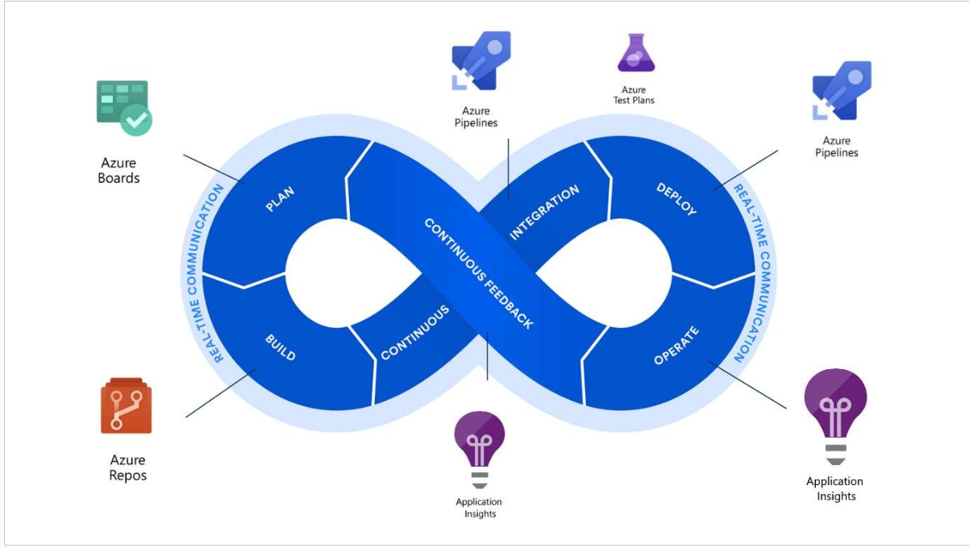

Normal DevOps:

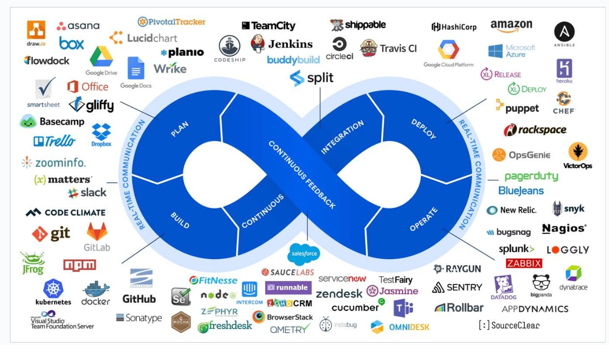

Setup:

1. Search for **azure DevOps**
2. Create an organisation
3. Create a project
4. Start exploring different Azure DevOps tools

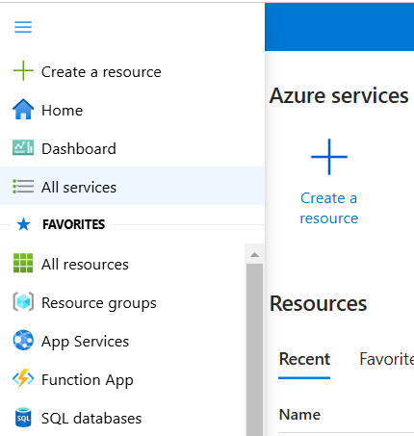

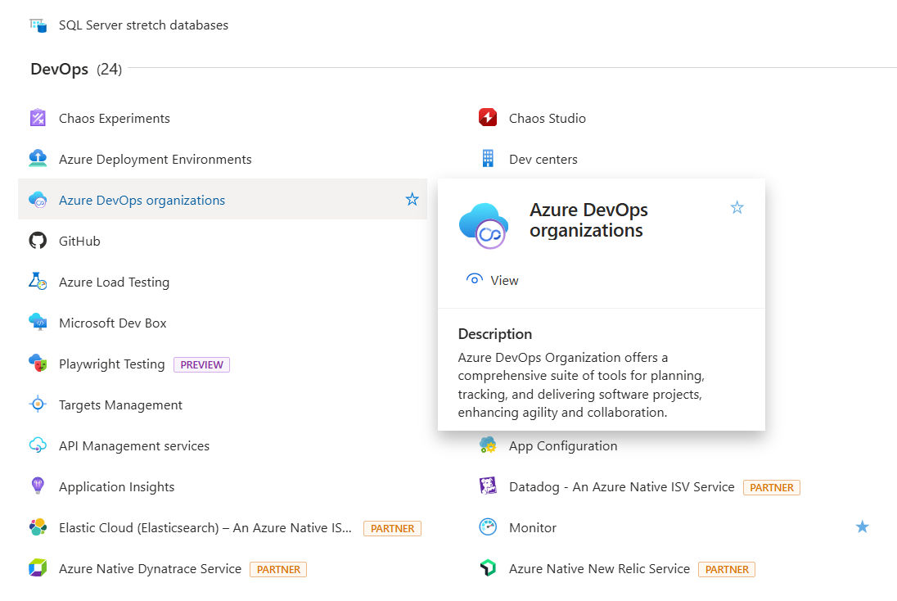

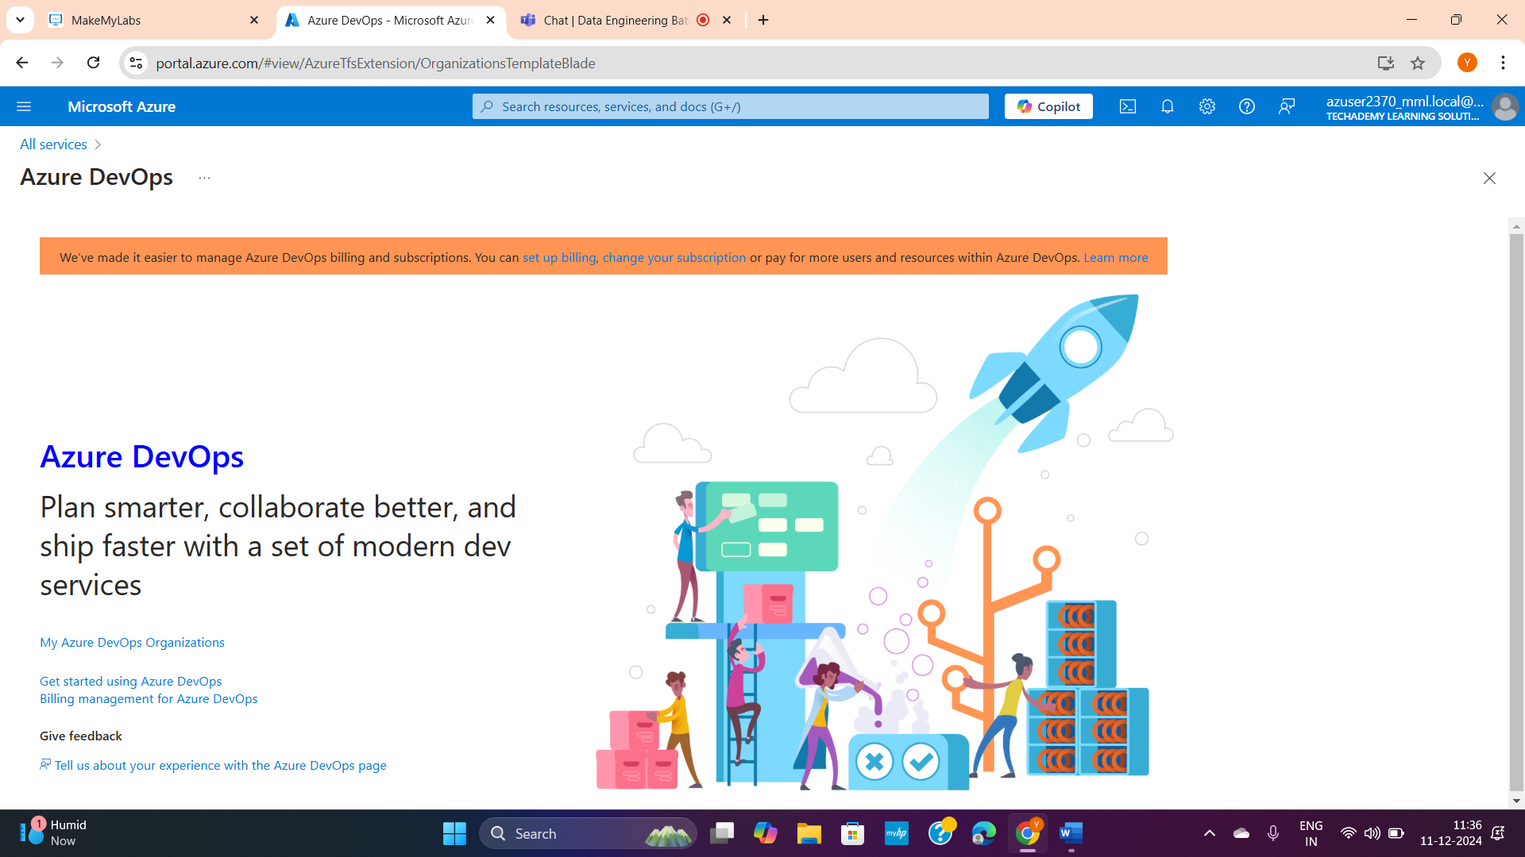

Click My Azure DevOps Organizations (above)

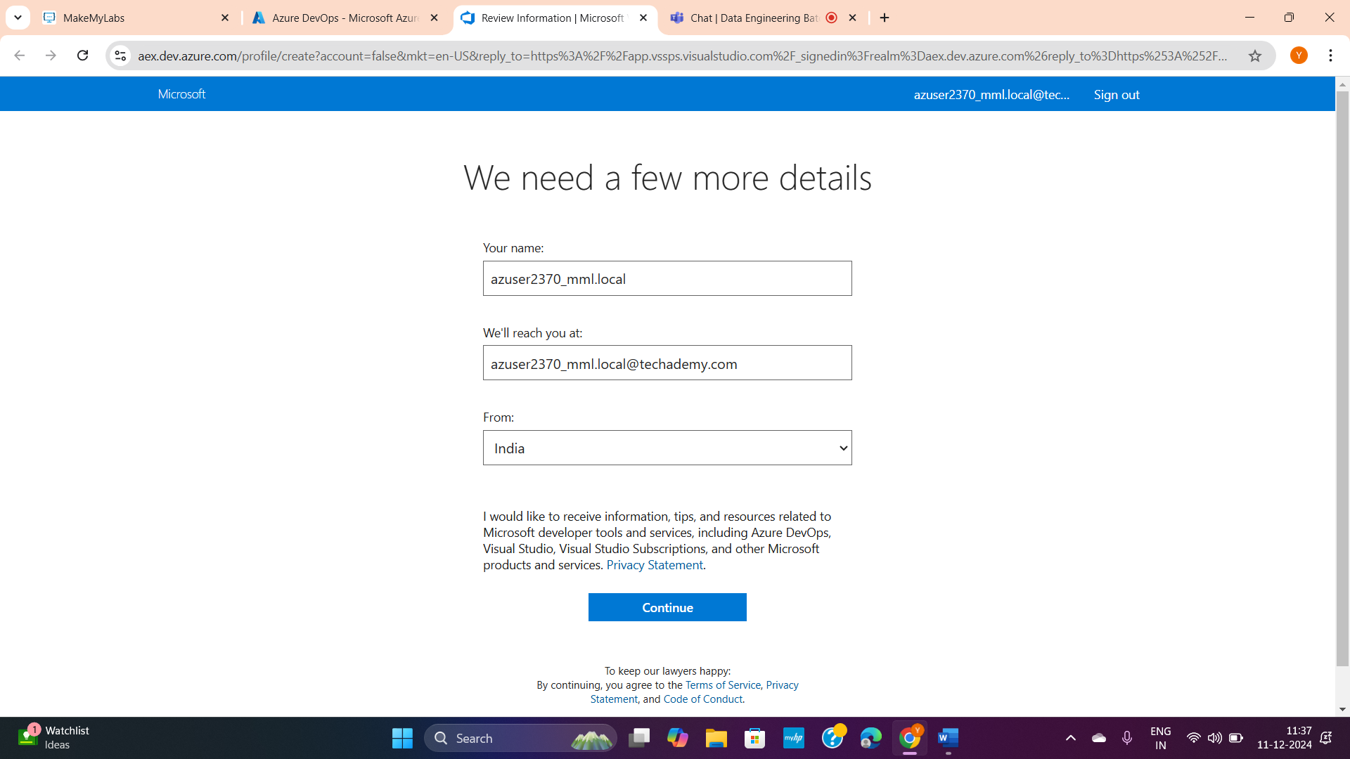

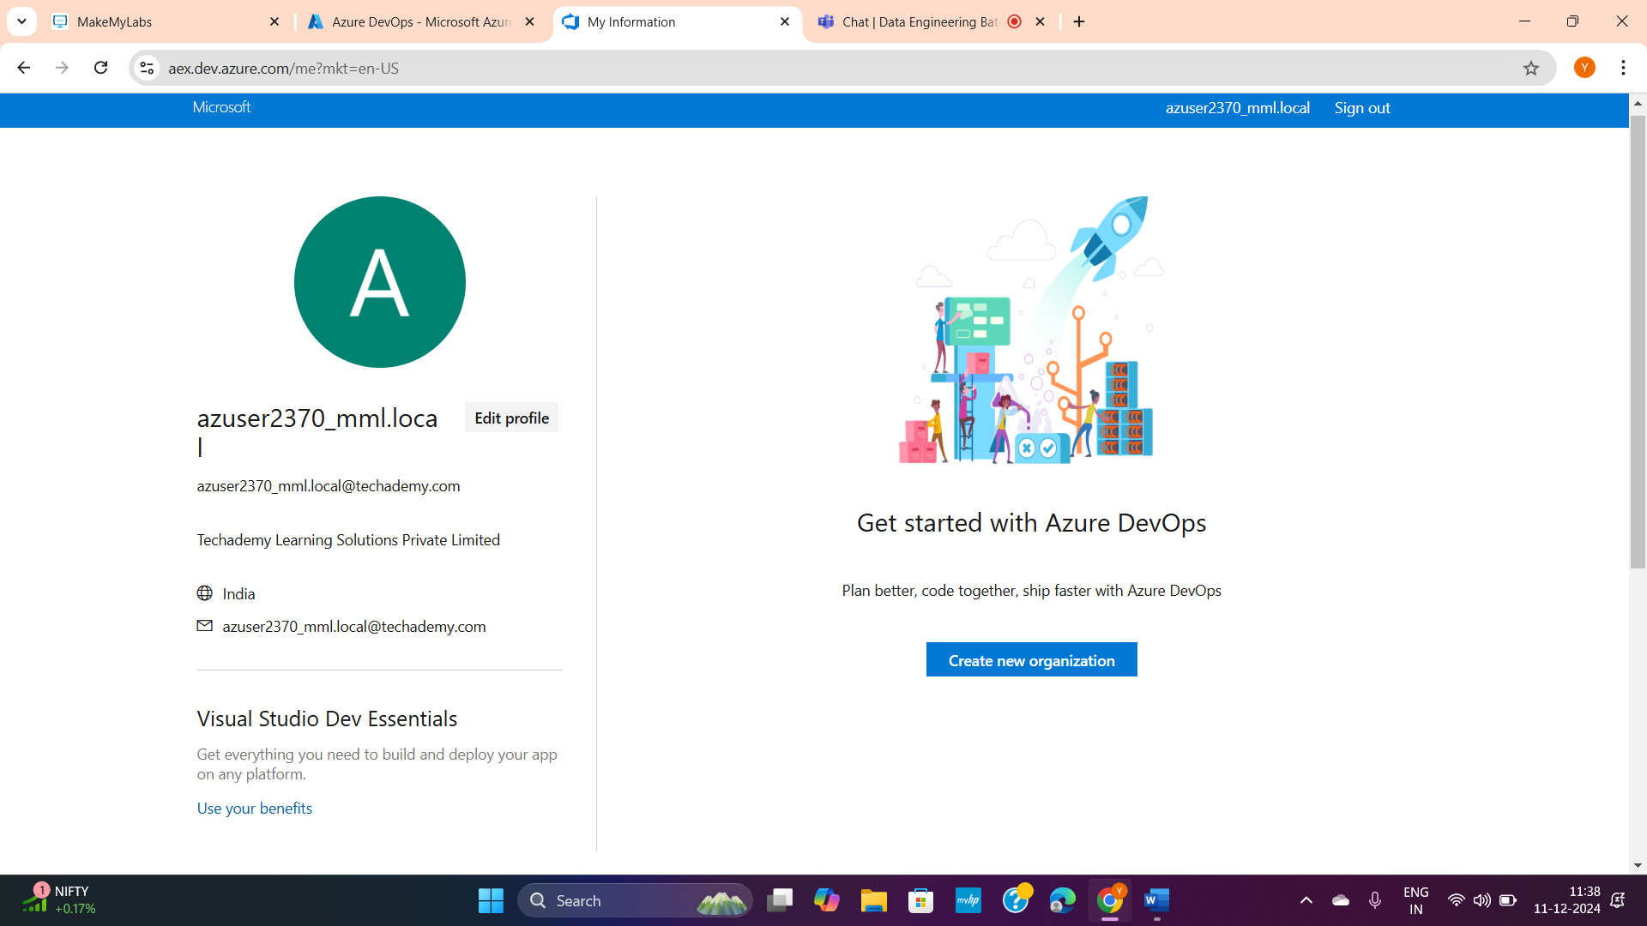

Create new organisation and click continue- continue

And create a project

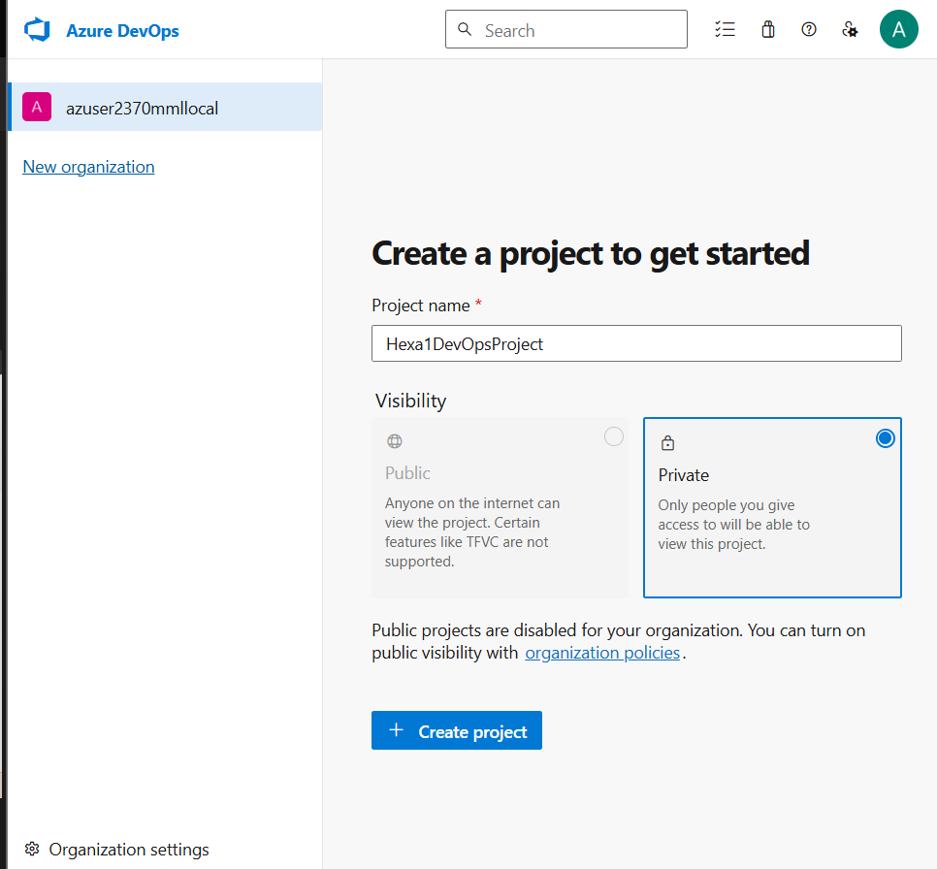

Successfully created your project inside your org

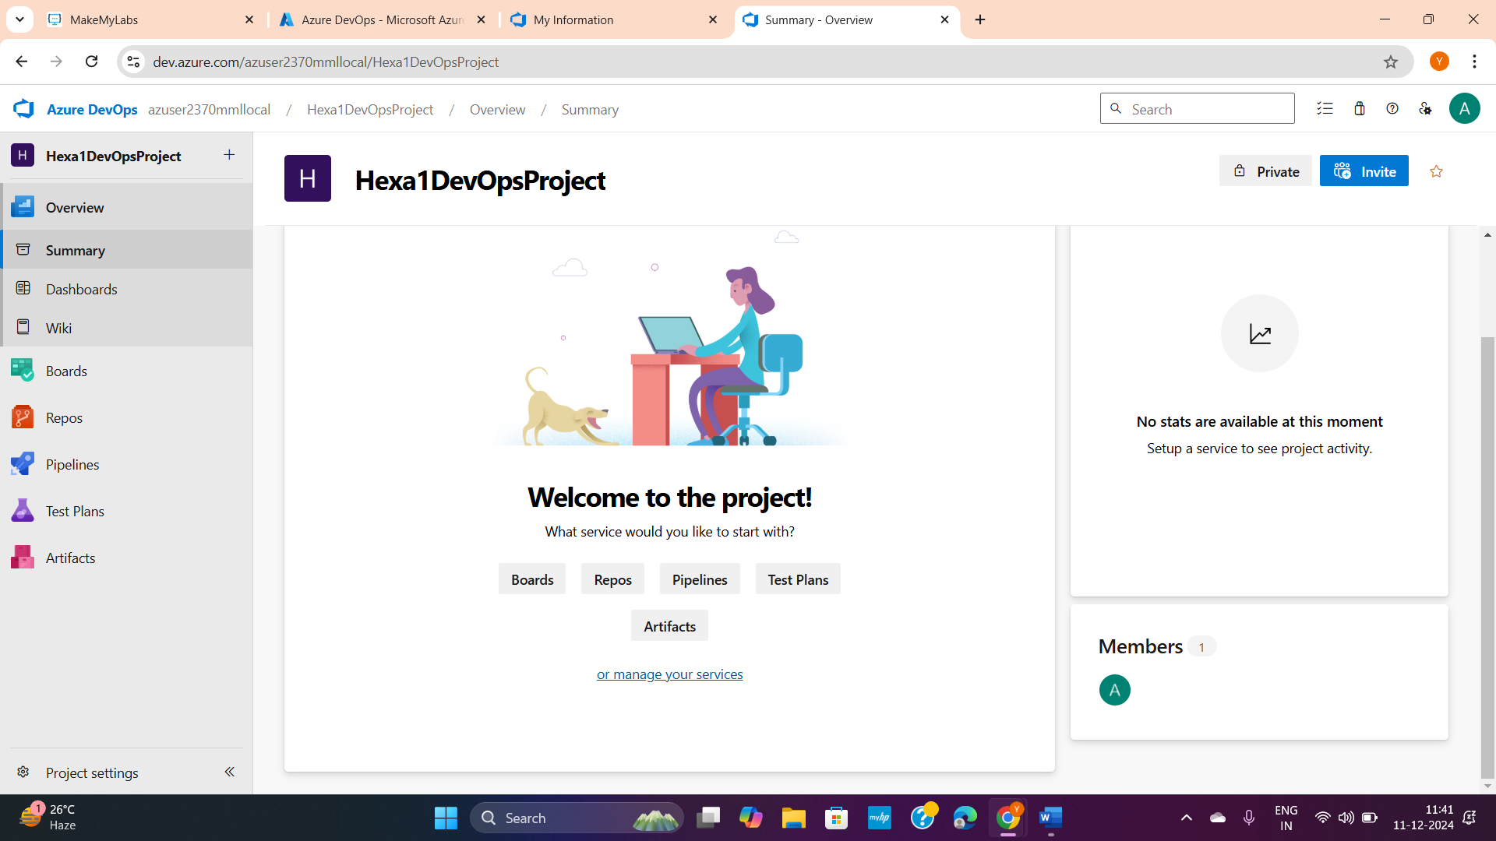

Planning tool ‘BOARD’ from first architecture picture (page1):

Now go to **Boards** >> New work item >> epic (This board is very similar to the **Trello** planning tool)

NOTE- Inside boards:

1. Work items 2. Boards 3. Backlogs 4. Sprints etc. all are interconnected.

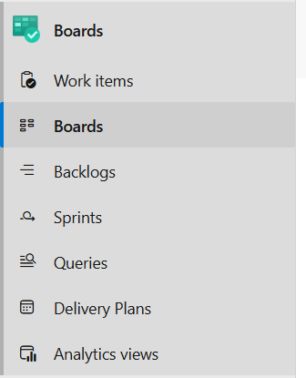

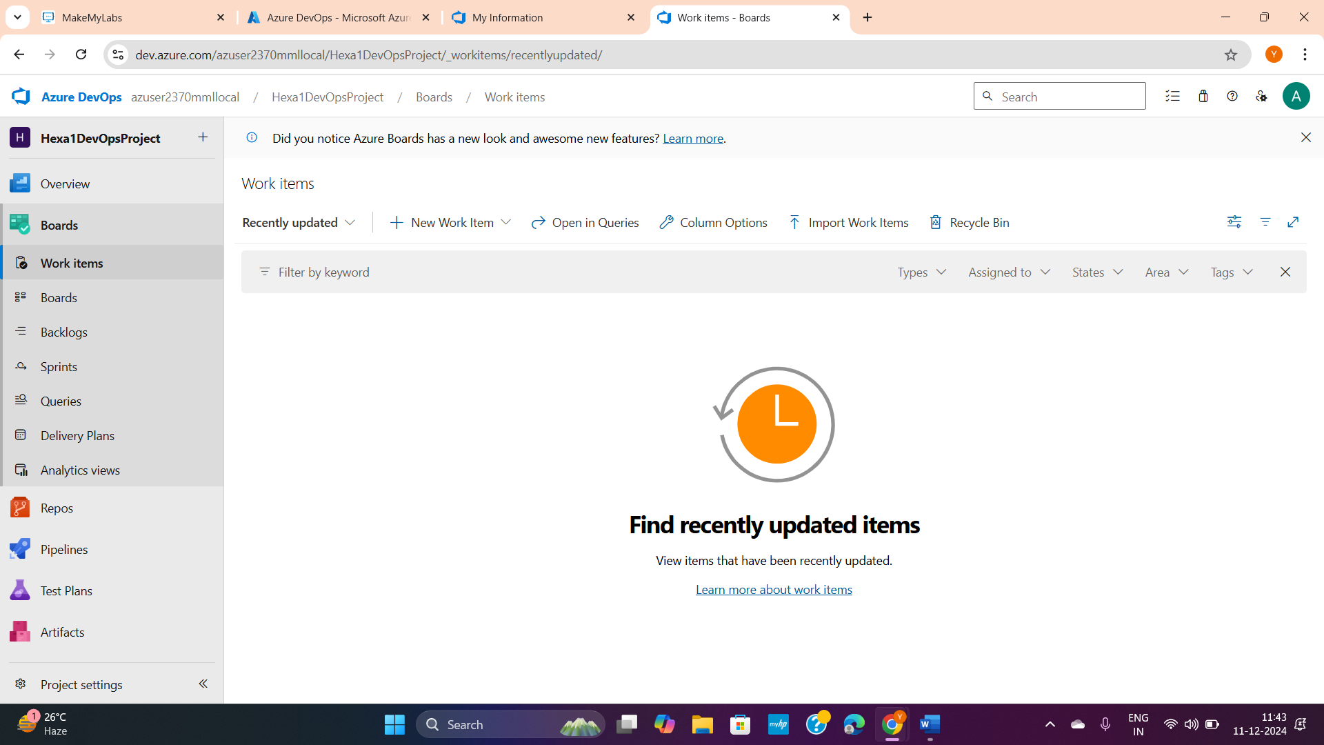

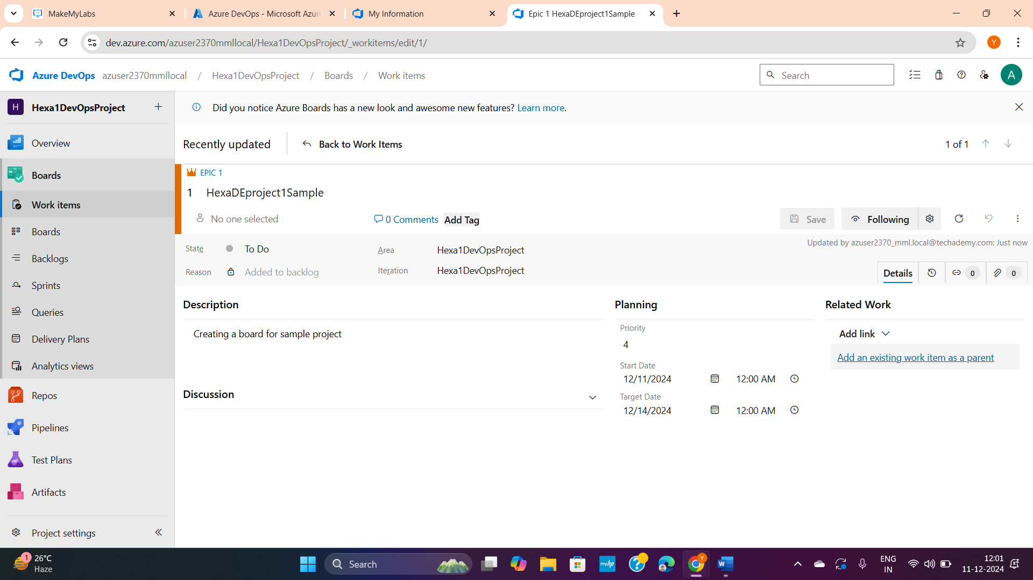

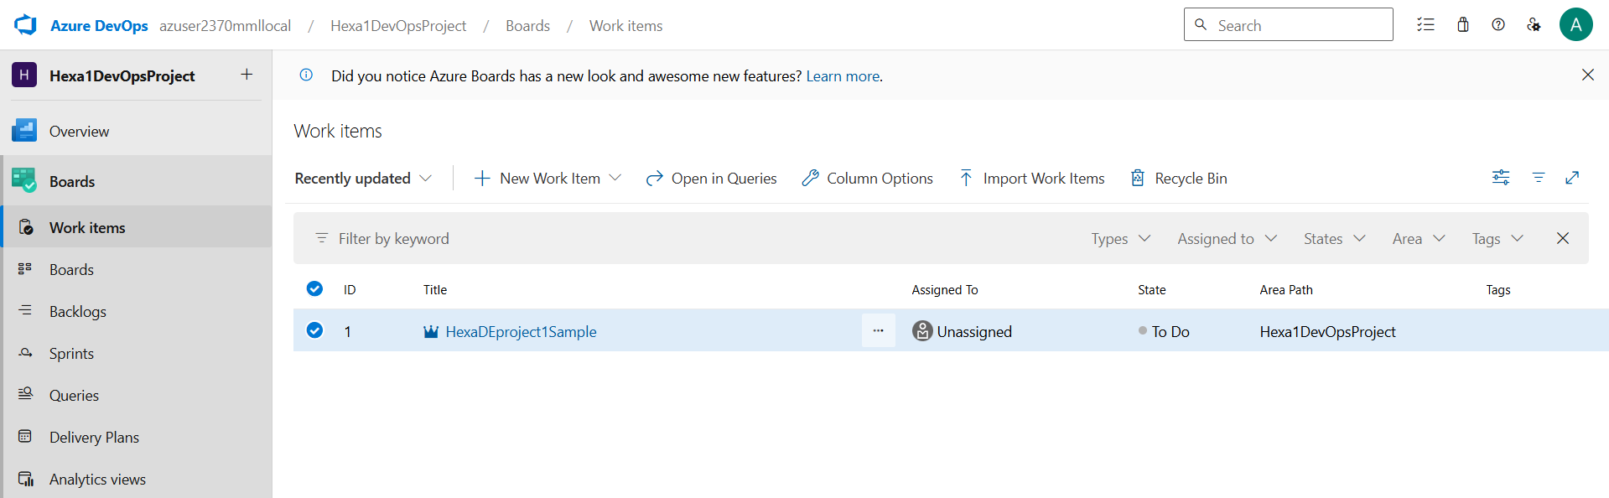

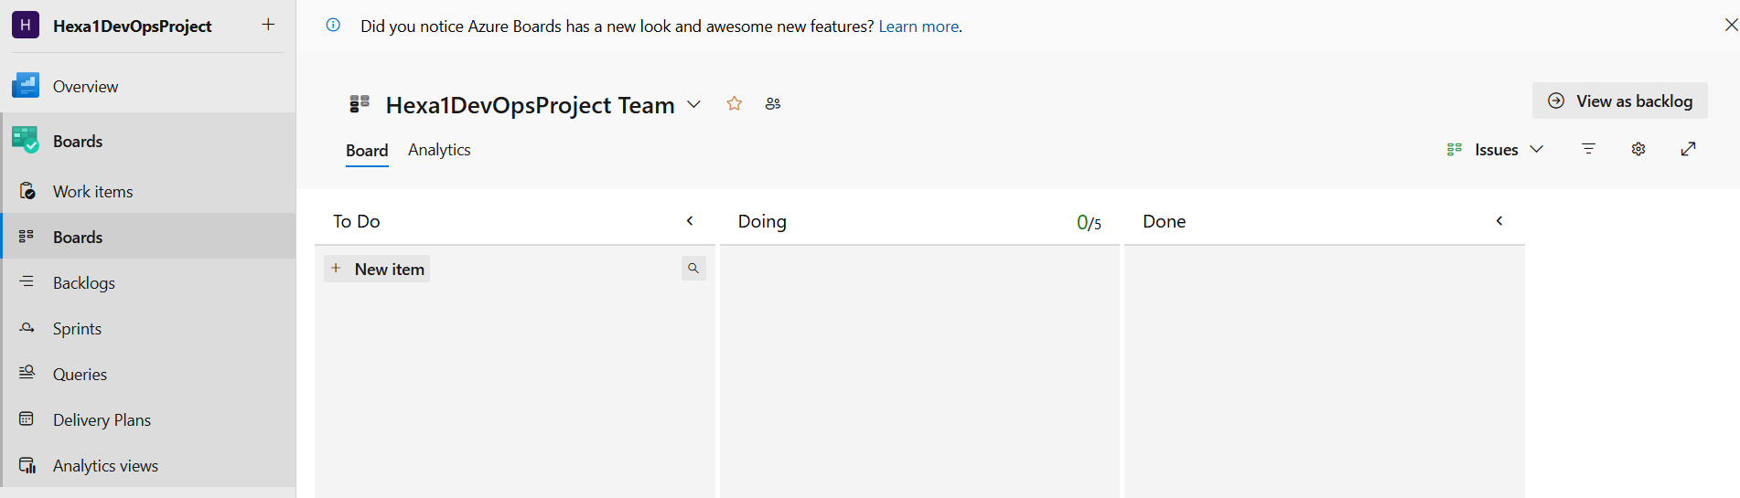

Features:

* Have to do list
* Have backlogs (things pending)
* You can add others to your prj board
* You can add timeline etc.